**1. Creating a Table:** Create a table named "Students" with columns: "student_id" (integer), "first_name" (text), "last_name" (text), and "age" (integer).

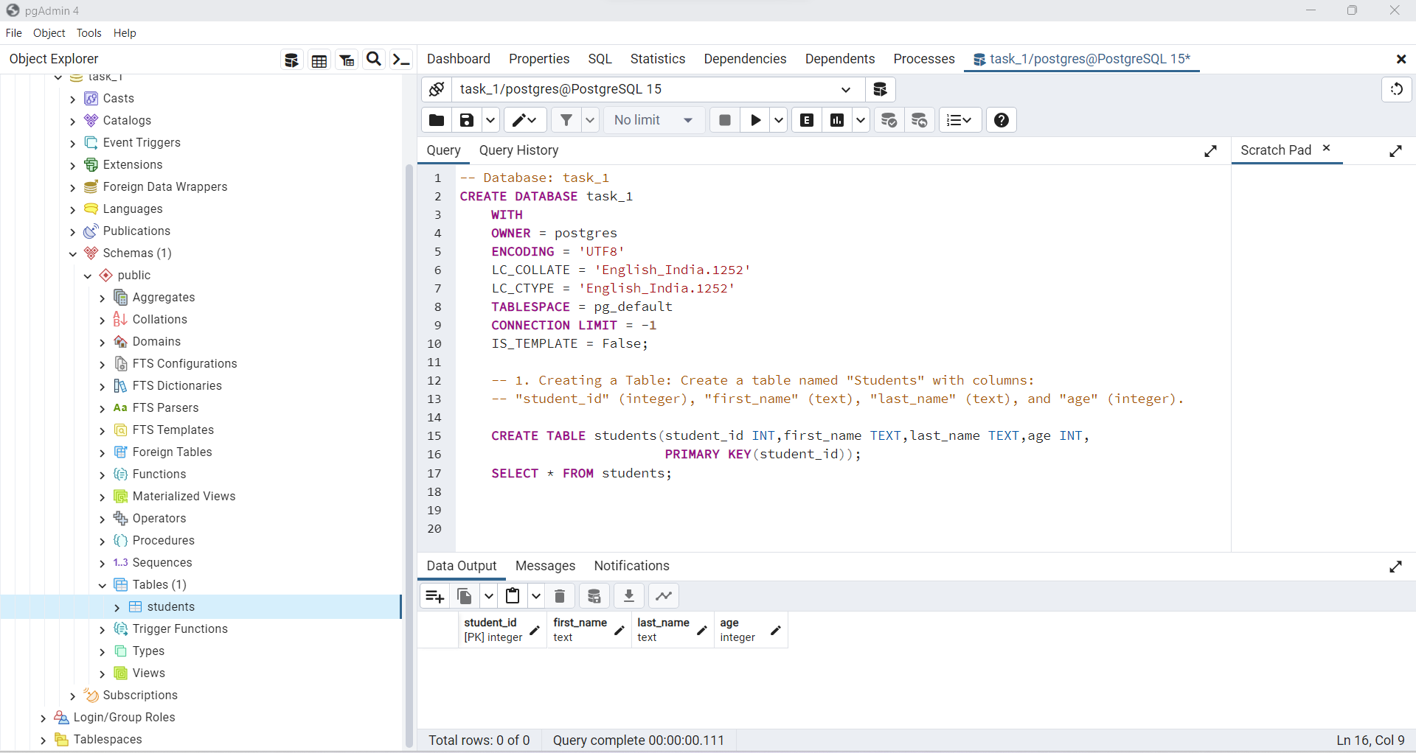

**2. Inserting Data:** Insert a few rows of sample data into the "Students" table you created in the previous exercise.

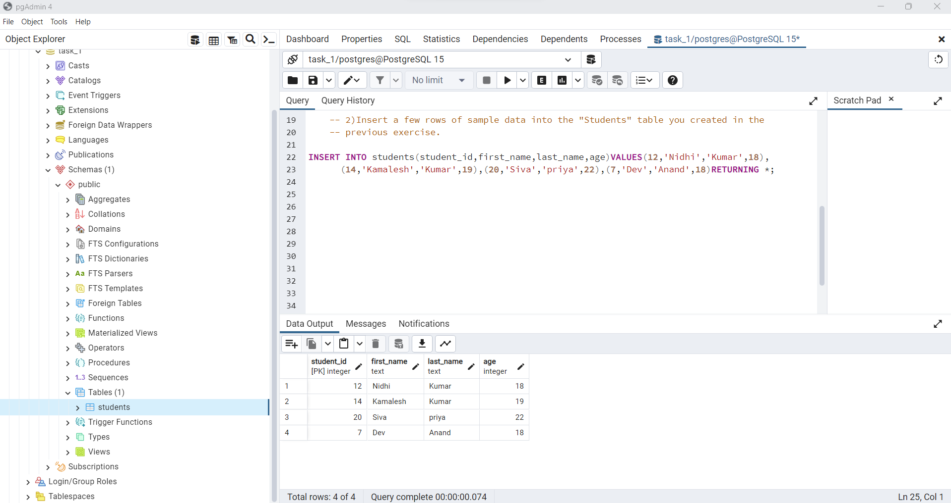

**3. Basic Queries:**

a. Retrieve all the records from the "Students" table.

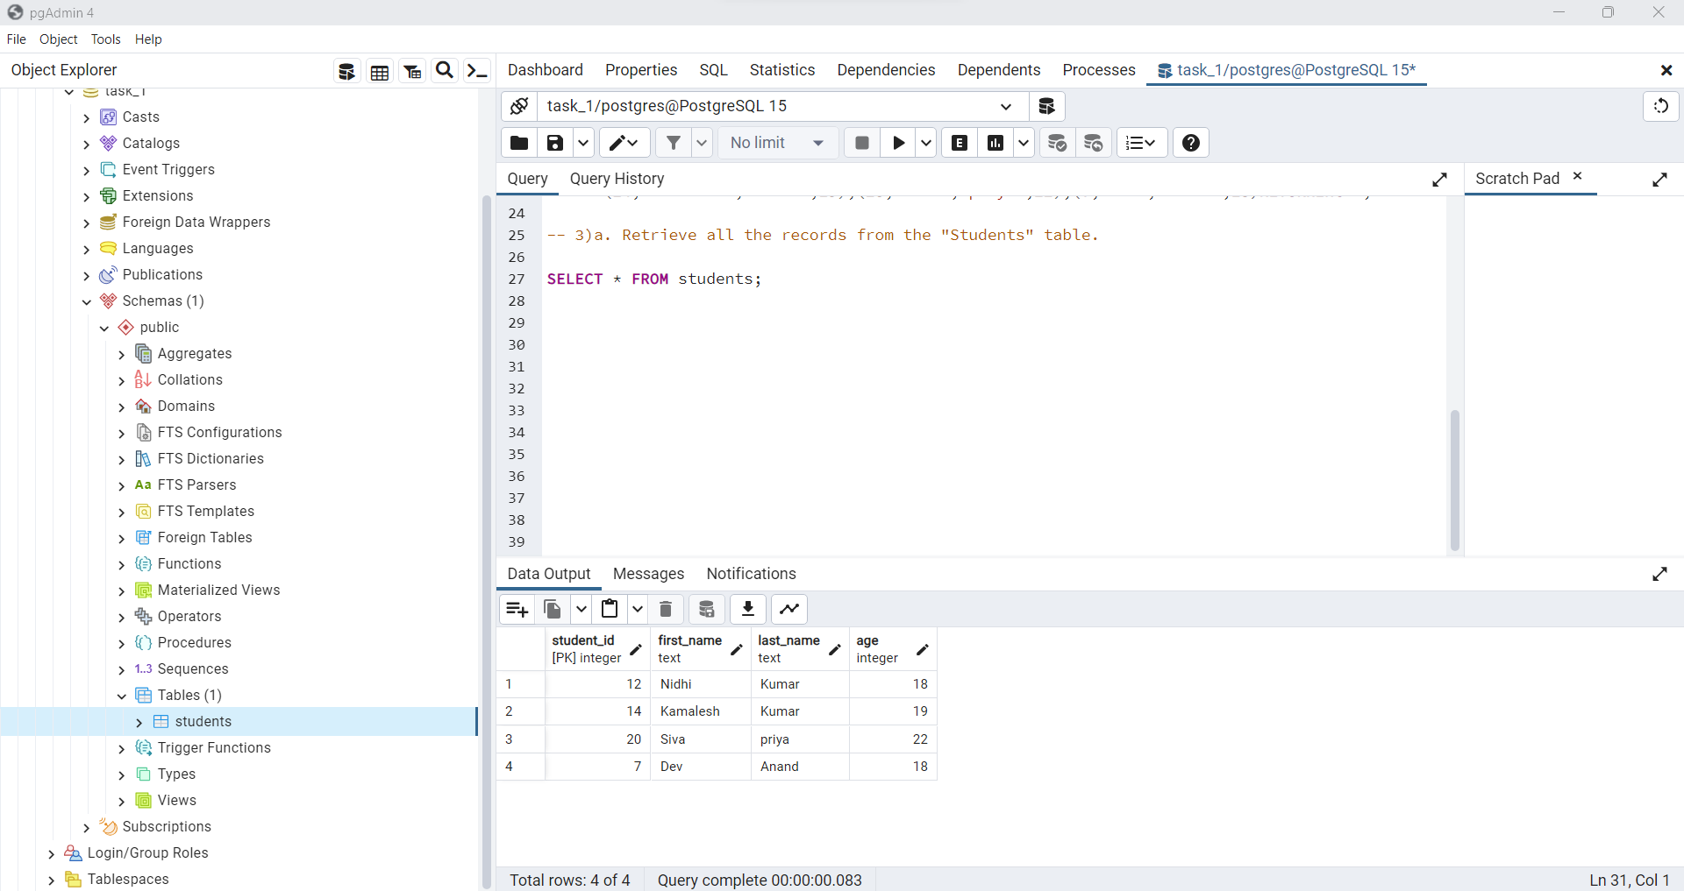

b. Retrieve the first and last names of students whose age is greater than 20.

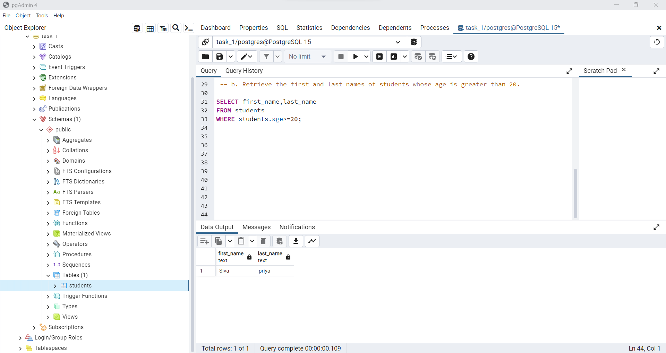

c. Count the number of students in the table.

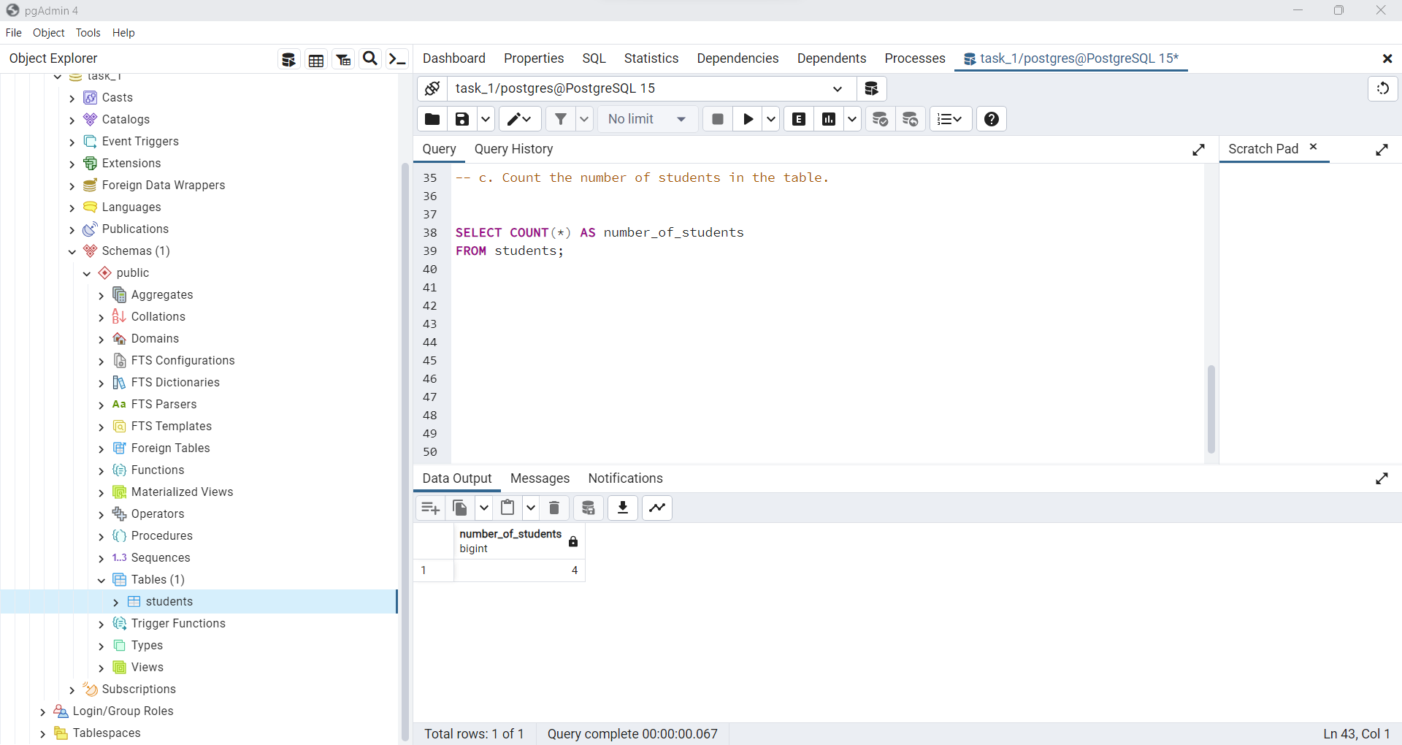

d. Retrieve the names of students in alphabetical order by their last names.

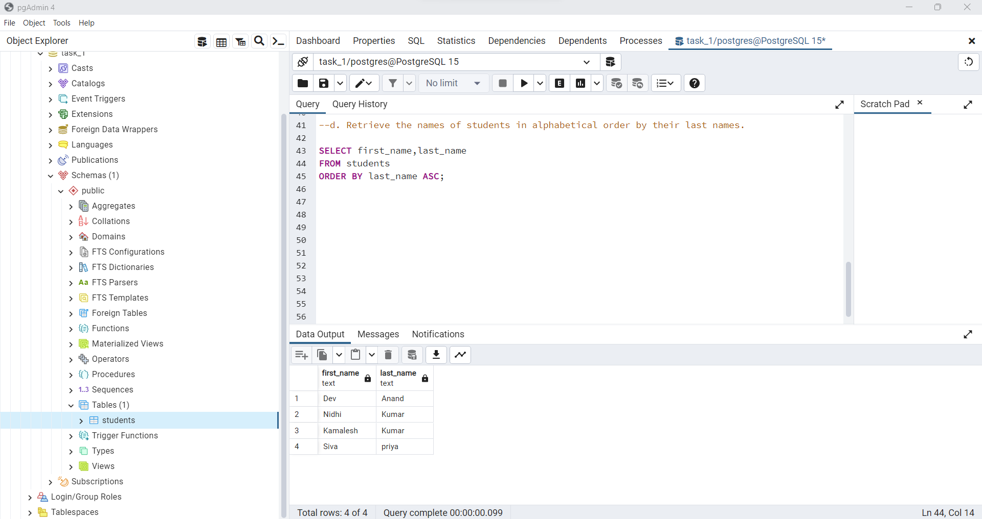

**4. Updating and Deleting Data:**

a. Update the age of a specific student in the "Students" table.

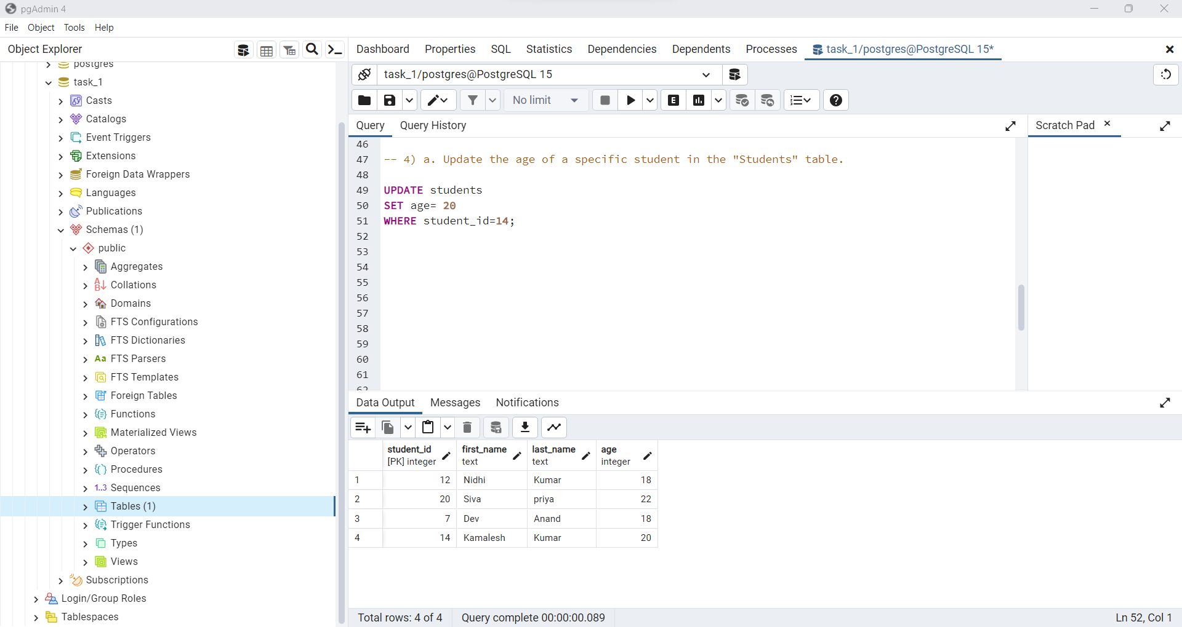

b. Delete a student's record from the table based on their ID.

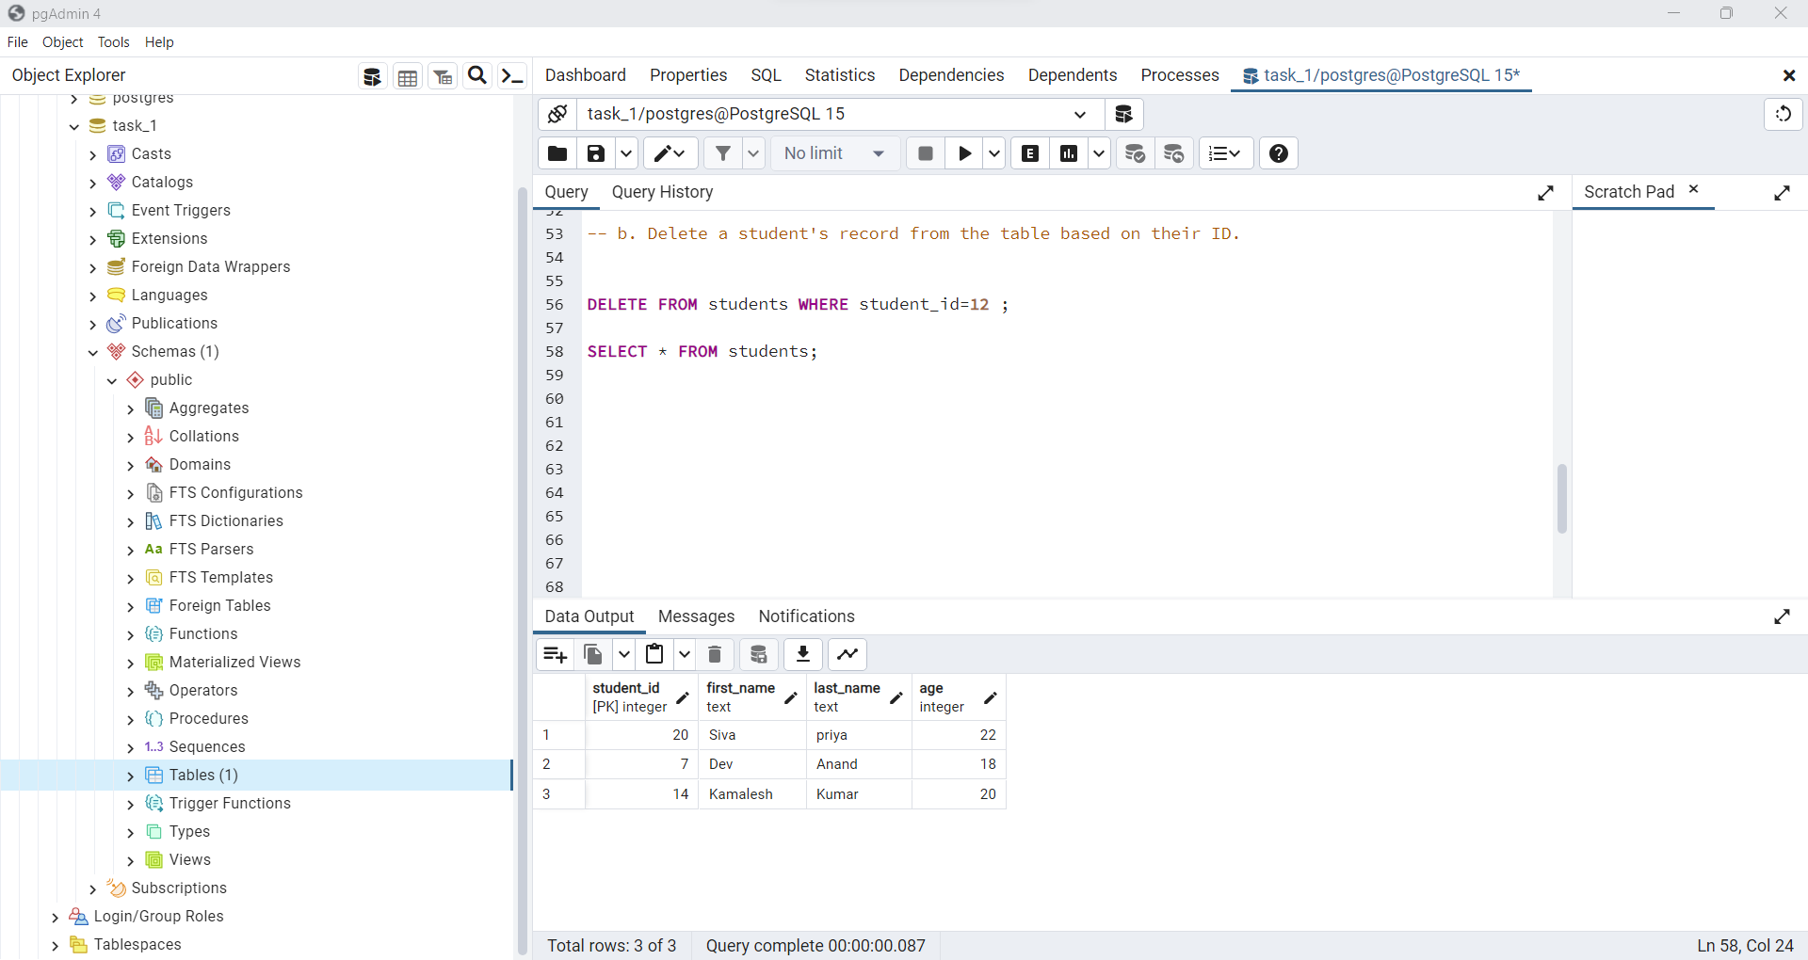

**5) Filtering and Ordering:**

a. Retrieve the first name, last name, and age of students aged between 18 and 25.

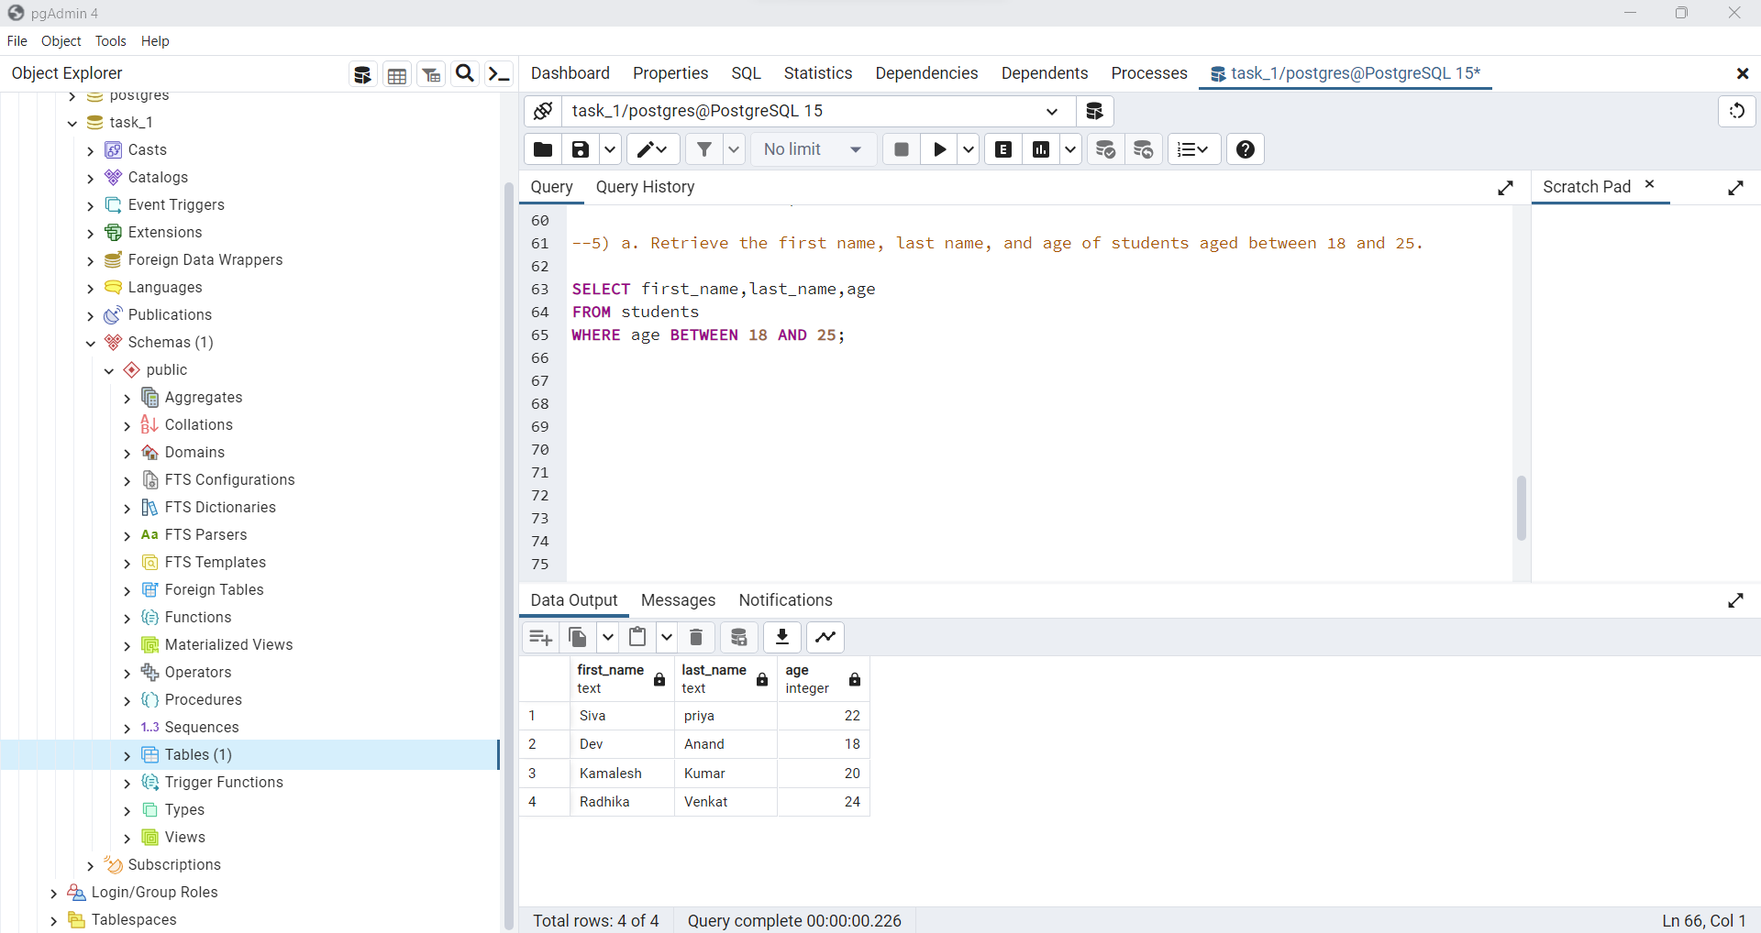

b. Retrieve the names of students in descending order of their ages.

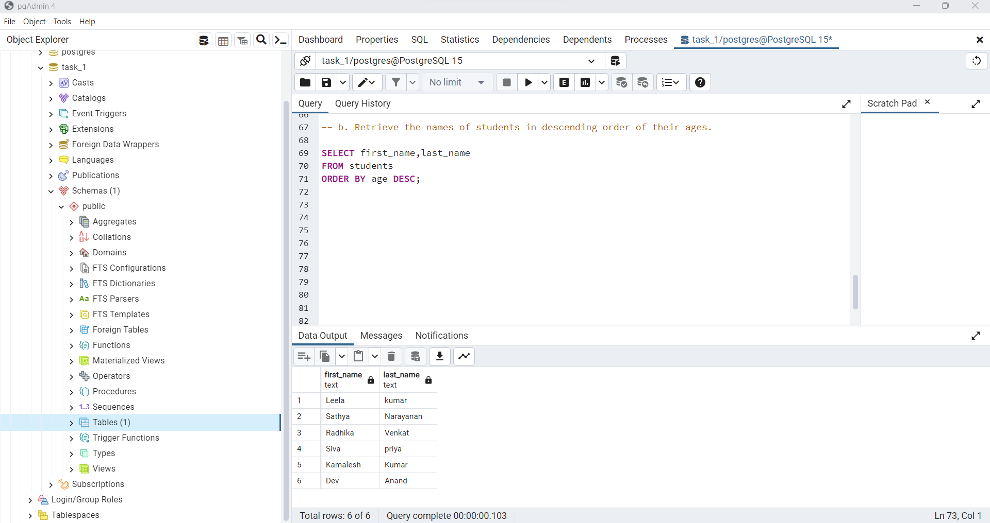

**6. Aggregation:**

a. Calculate the average age of all students.

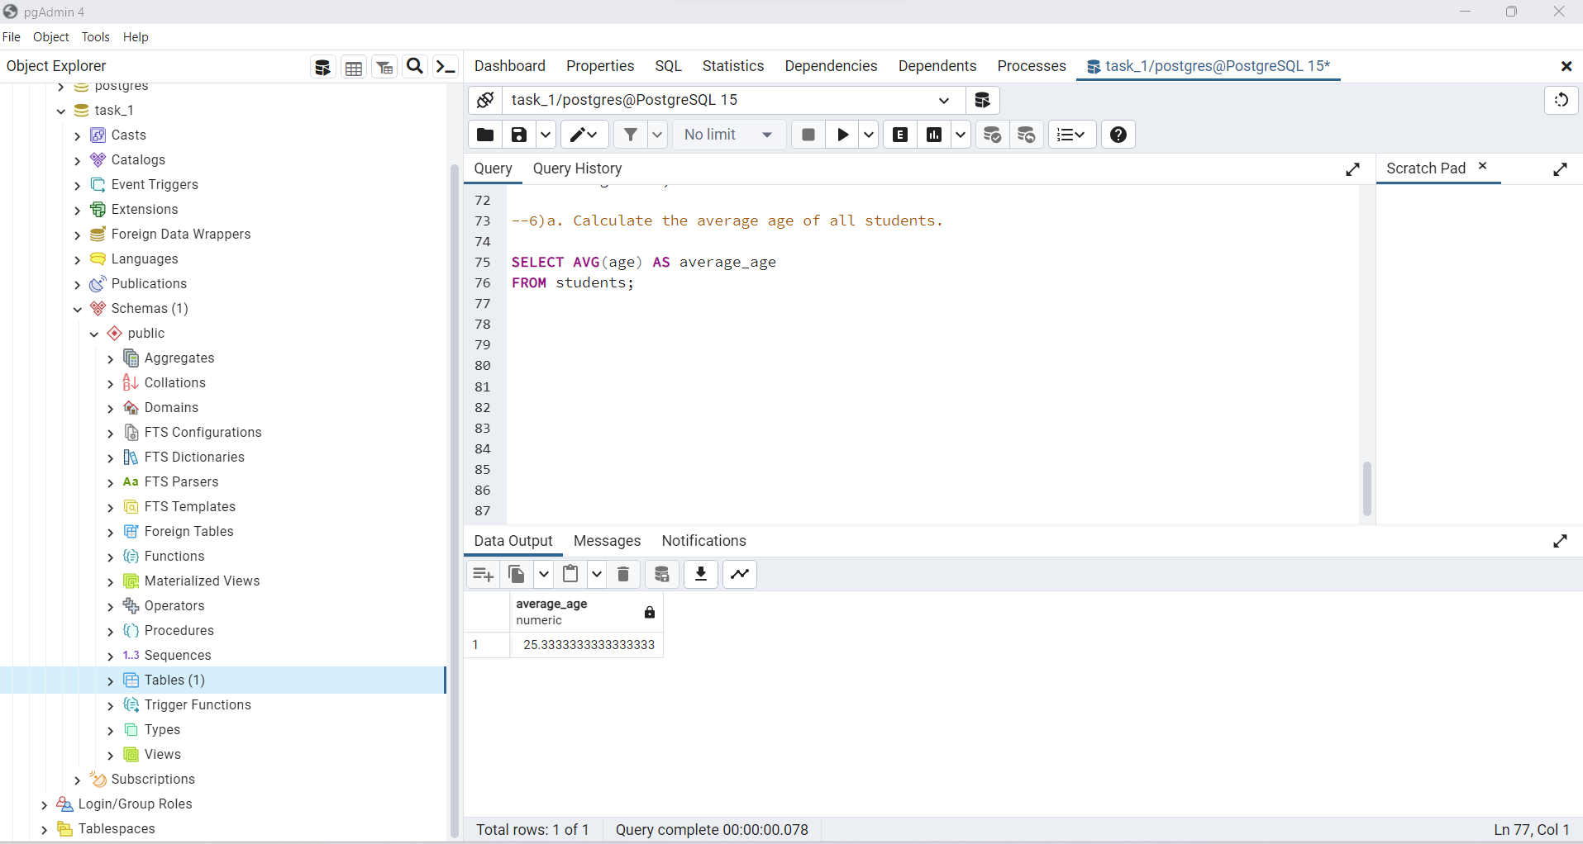

b. Find the maximum age among all students.

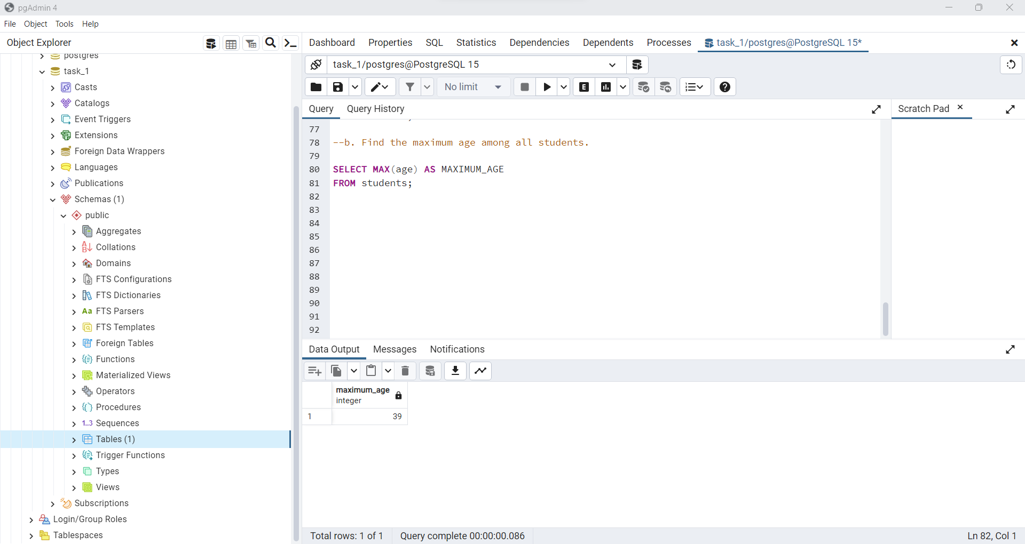

c. Calculate the total age of all students.

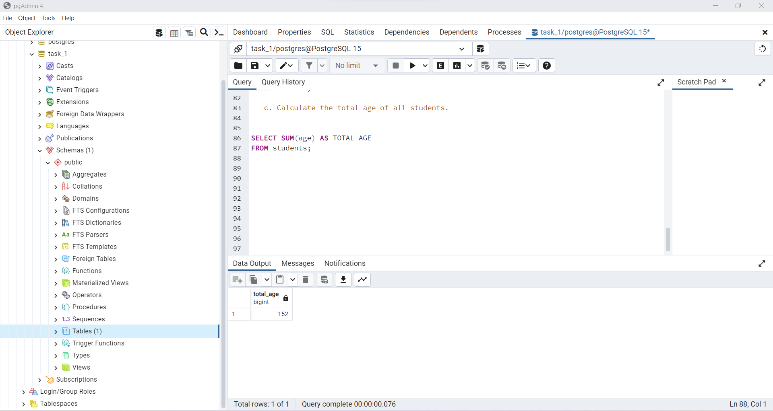

**7. Grouping and Aggregates:**

Retrieve the count of students for each age group (e.g., 18-20, 21-25, etc.).

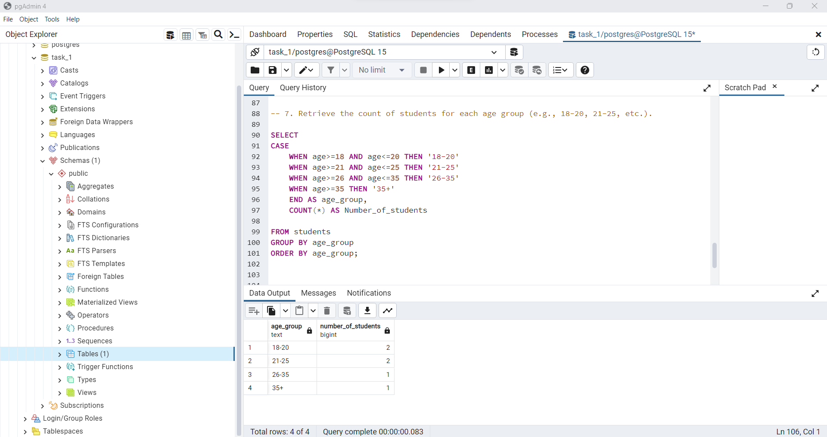

**8. Joins:**

a. Create another table named "Courses" with columns: "course_id" (integer) and "course_name" (text).

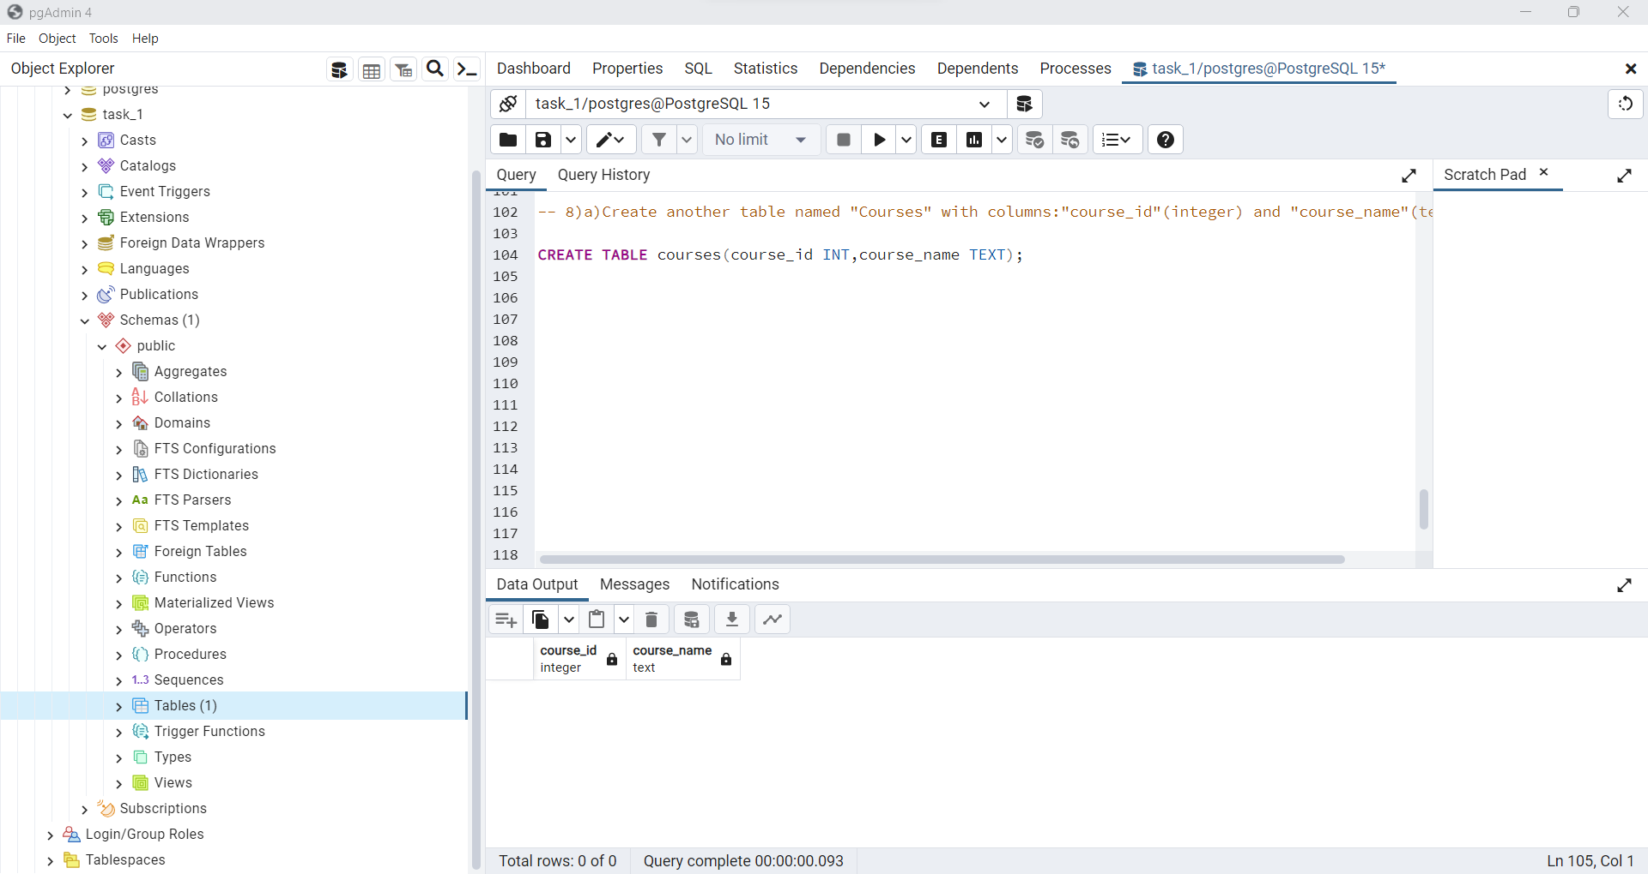

b. Insert some sample course data into the "Courses" table.

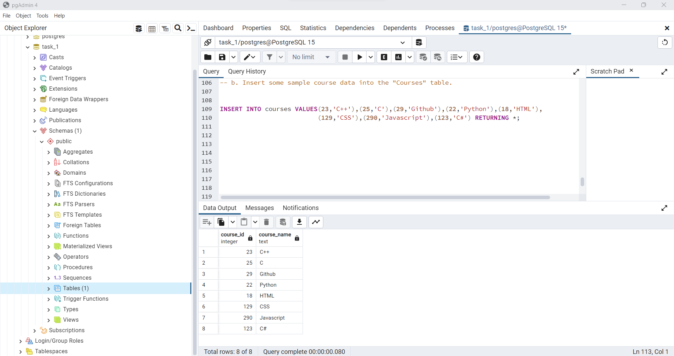

c. Create a new table "StudentCourses" with columns: "student_id" and "course_id" to represent a many-to-many relationship between students and courses.

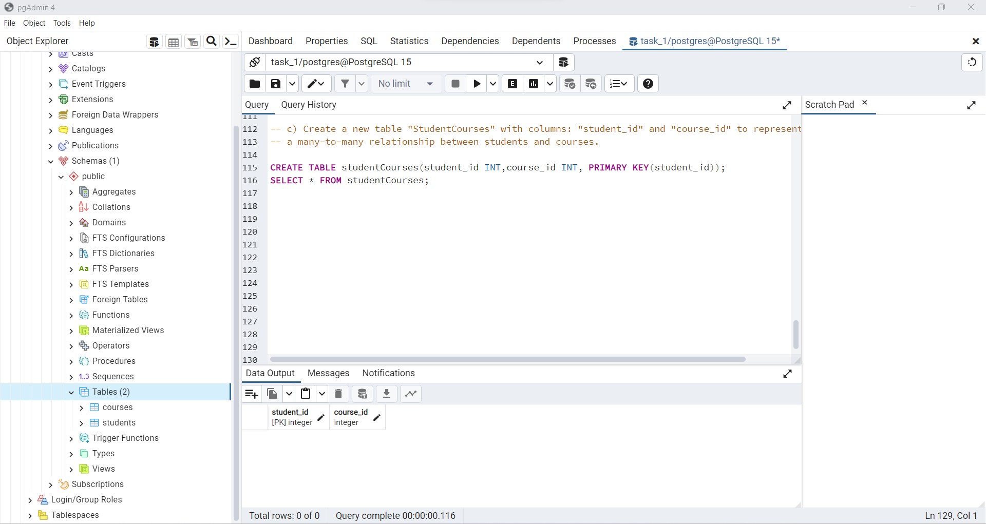

d. Insert sample data into the "StudentCourses" table.

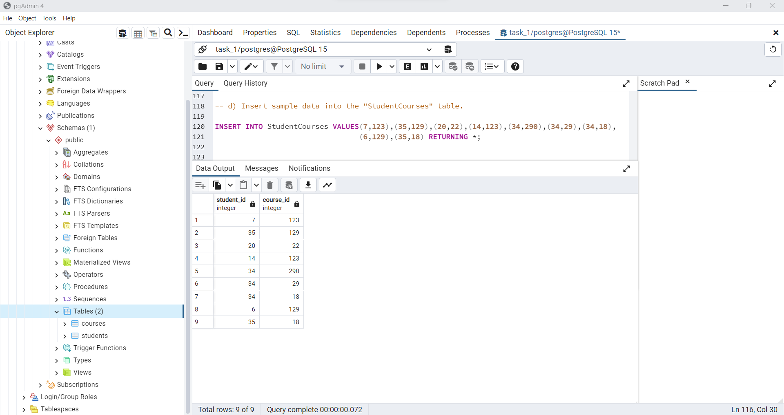

e. Write a query to retrieve the courses taken by a specific student.

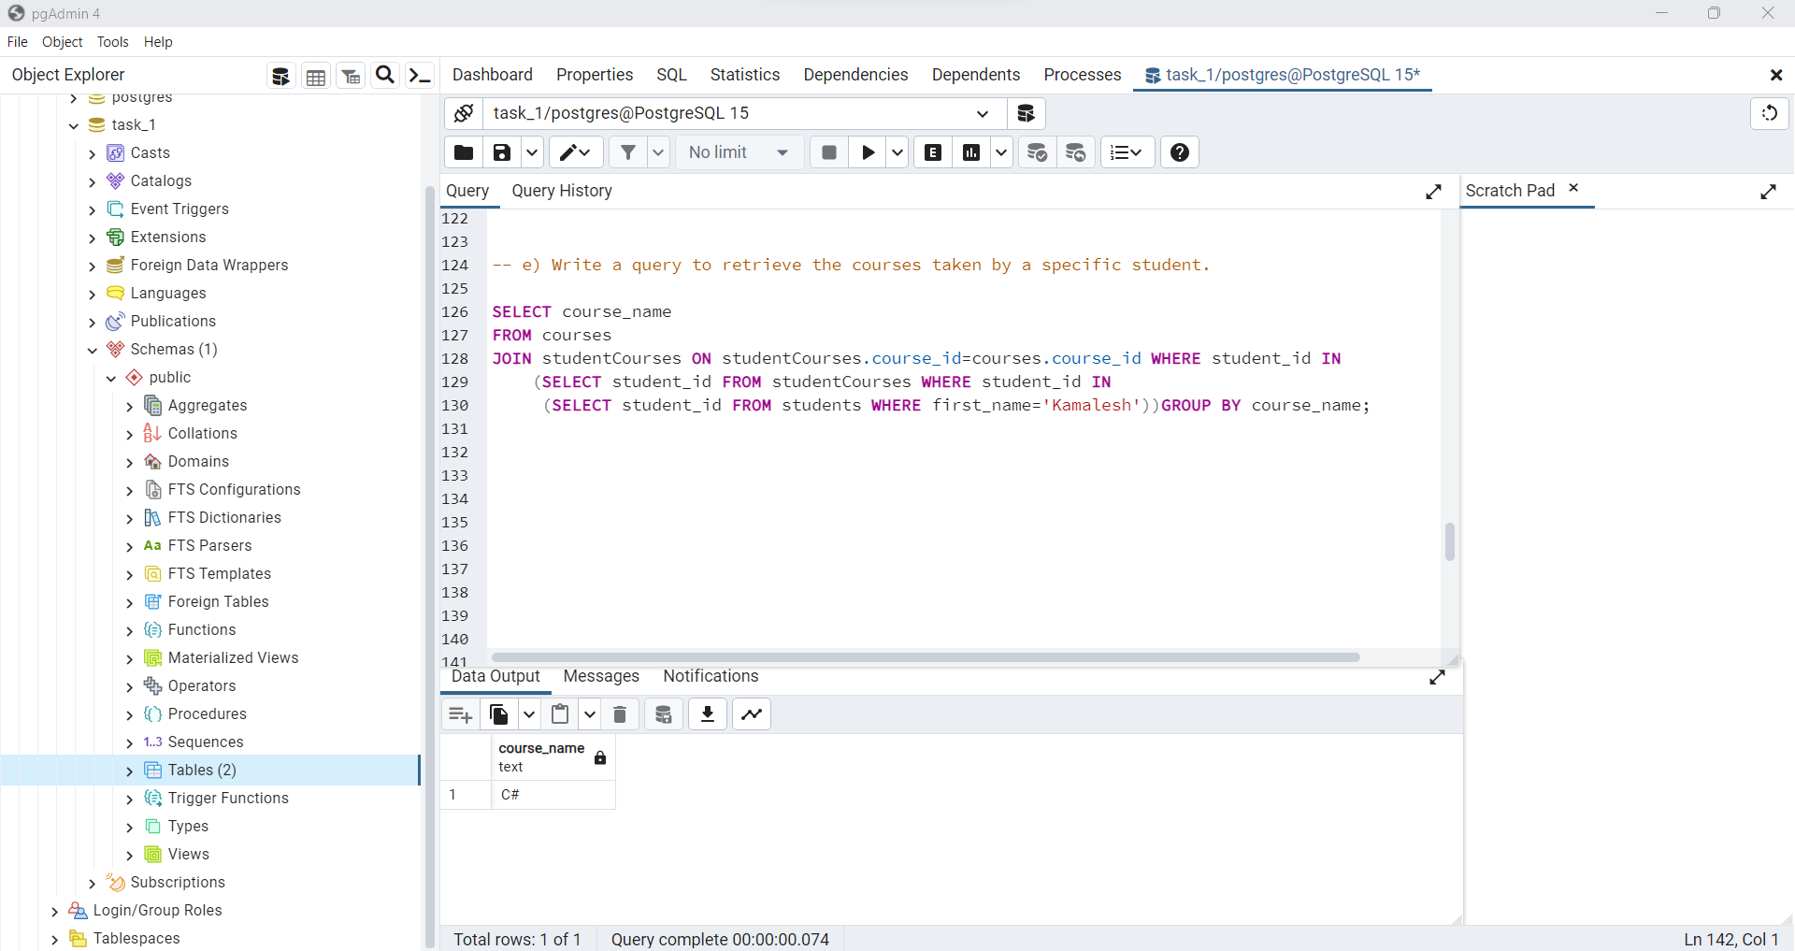

**9. Subqueries:** Retrieve the names of students who are enrolled in a course named "Mathematics."

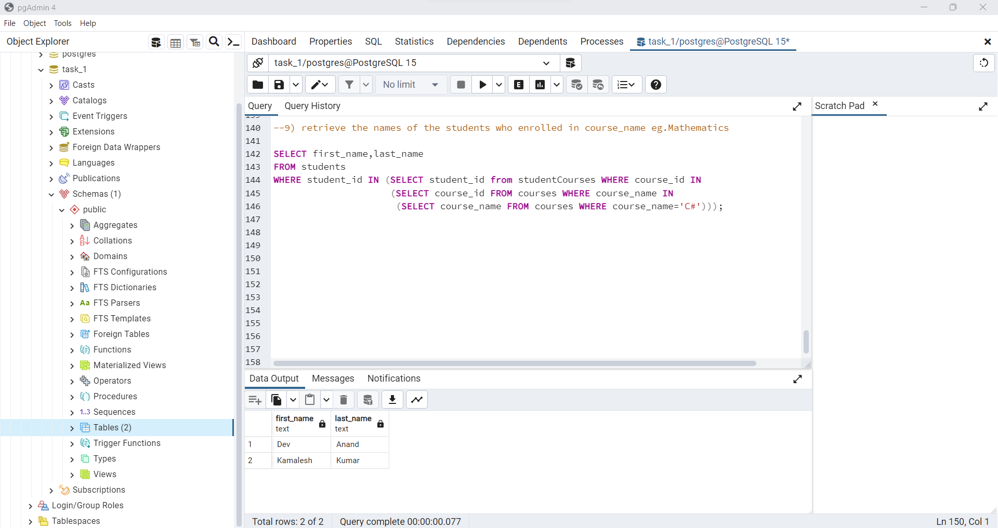

**10. Using LIKE and ILIKE:** Retrieve the names of students whose last name contains the letter "s."

